Features & Implementation:

* Employed Twitter Bootstrap responsive grid system and optimized for various size screens (monitor, iPhone, iPad, etc.)
  + View in large-size screen: (This is just part of the website, for more details please look at the website itself. The same as the screenshot below



* + View in medium-size screen:



* + View in small-size screen:

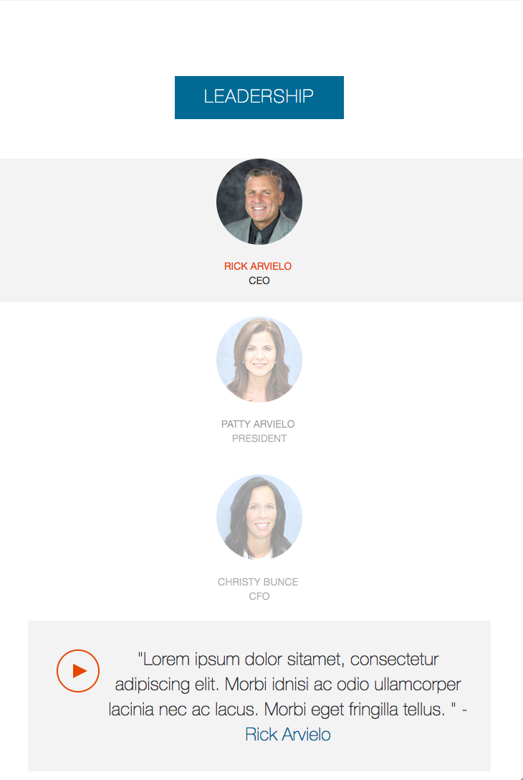

* Used Browser Sync tool to spin up local server for viewing the page in the process of development.

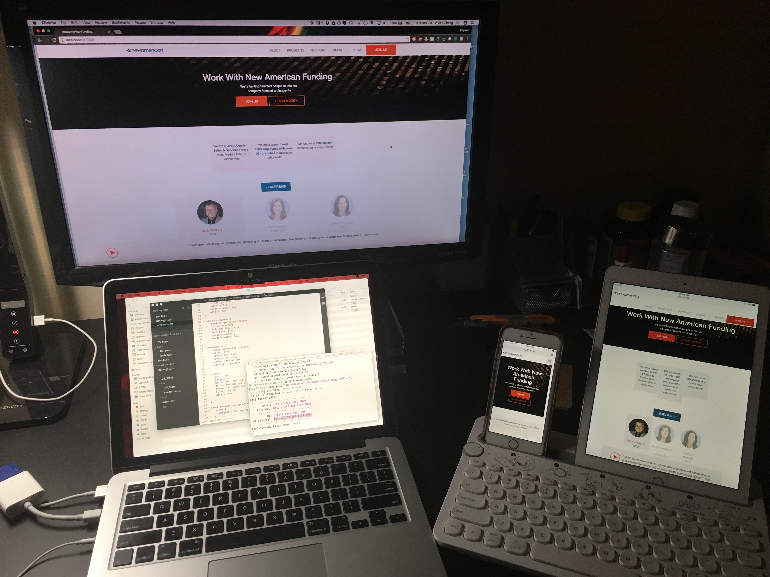

* Used SCSS for cascading style sheets
  + Variables
  + @media
  + @extend
  + nesting
* Used Gulp for automatically
  + converting SCSS file to CSS,
  + minifying CSS file,
  + employing Browser Sync and live view mode

upon on file changes

* Used jQuery to implement the hover effect of the Leadership. The default view of the leaders picture session is done based on the PDS file in the assignment.

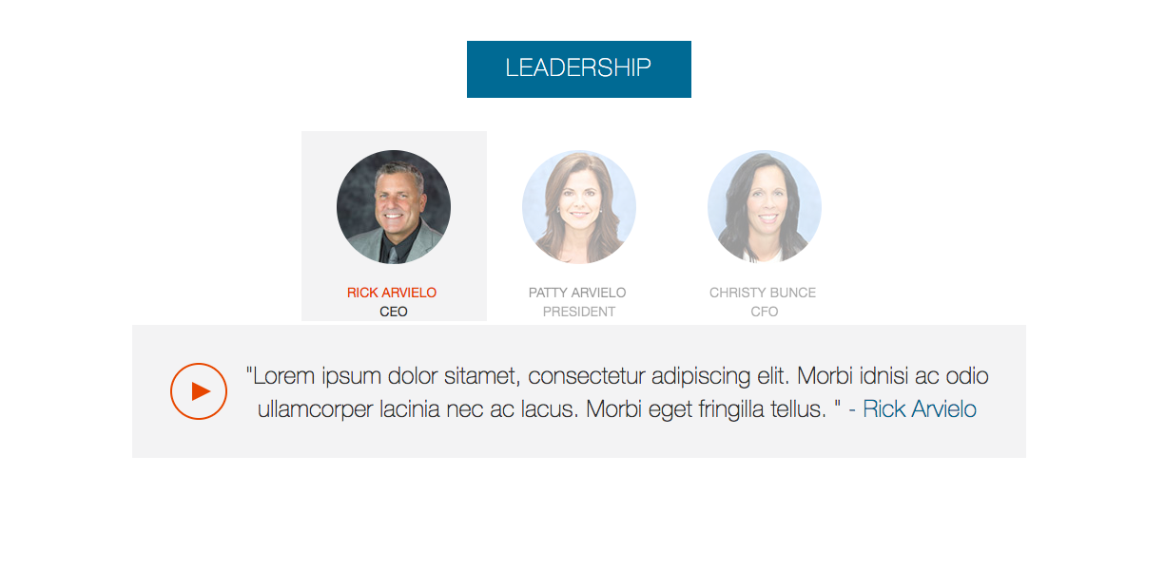

To see the hover effect, put mouse on another leader’s picture. The person’s name will be highlighted at the same time.

